Planet X Nibiru Projected Orbital Return 2012 AD
Planet X and Sumerians Nibiru - Mayan Tzoltze ek' one in the Same?
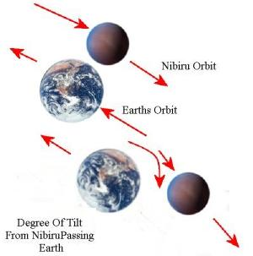
Greetings and Welcome to the Planet X Files!
The equations that follow are real. The numbers have not been changed to protect the innocent. The consequences will be real. I've done my very best to keep it simple so anyone can follow along and understand. There are no "doomsday" predictions here, but this event will take place. Knowing this can save the life of you and yours. My personal advice should headlines start creeping around by 2010? By late 2012 = stay away from the coasts.
Click here for complete 2012 scenario
Utilizing several timeline scales - pick what works for you: - tya = thousand years ago
Age of Taurus = 4500 BC = {4,286 - 2,143 bce} = (4-6 tya)
Age of Gemini = 7500 BC = {6,429 - 4,286 bce} = (6-8 tya)
Age of Leo = 11,500 BC = {10,715 - 8,572 bce} = (10-12 tya)
Age of Virgo = 14,500 BC = {12,858 - 10,715 bce} = (12-15ya and on)
Nibiru - Sumerian Definition 4200 BCish
Tzoltze ek' - Mayan Definition 3800 BCish
Planet X - Modern Astronomy Science
"modern day definition": Planet X aka Nibiru:
A large scale hypothetical planet that's part of our solar system with an orbit beyond that of Neptune. Was first hypothesized in 1841 when astronomers noticed Uranus did not move as predicted in it's orbit. Based on these residuals, the search for Planet X began.
Please keep in mind, I'm not a graphic artist. (doh) But most importantly, the dates illustrated below are just to ROUND OFF for purpose's of simplicity. The current figure generally accepted by science is that planet x/nibiru is on a 3600 year elongated (elliptical) solar orbit.
My personal calculations put this at 4320.26 years <---!!!Wrong!!! (See Below). Since this is closest to 4000 years I thought it would be fair enough when referring to a chronological scale of human/earth history.
This means that PlanetX/Nibiru is visible every 2000 (2,160) years during its orbital pass. ( Sumerian and Mayan text both state that Nibiru is clearly visible by day as well as night )
That being said, all science arenas confirm that the below charted events took place in the past at around those periods. The debate of course, is when exactly they occurred, and what exactly caused them to occur which isn't relevant for our purpose. You'll clearly see that the timeline's show something happens on a catastrophic scale every 4000 years (or so).
The sumerians told us that Nibiru wreaks havoc with the earth's axis every second orbital pass. (Every 4000 years or so). Basically, Earth's axis precessed from a right tilt forward and probably 180 to the left in around 10 or 20 hours due to the gravational "jolt" that takes place.Hmmmmm...
Sumerian Mathmatics 101 The Sumerian sexigesimal system of numbers works with changing factors that increase by 6 and 10.
The formula equates as follows:
1, 10, 60, 600, 3,600, 36,000, 216,000 bla bla so on, etc.
Every other preceding number is multiplied by 6 or 10.
The number 5,000 is written as 12,320 in Sumerian.
3,600 600 60 10 1
------------------------------
1 2 3 2 0 ---- thus,
1x3600 + 2x600 + 3x60 + 2x10 + 0x1 = 5,000. Still hanging with me?
If we look at the number 3,600 and write it
down the Sumerian way, we see that the result is 2,160.
3,600 600 60 10 1
--------------------------------
N/A 3 6 0 0 ---- thus,
3x600 + 6x60 + 0x10 + 0x1 = 2160.

The Sumerian mathmatics system might seem odd at first, but it's actually ideal for geometry, calculation with fractions, and time. The hour was divided into 60 minutes of 60 seconds each by the Mesopotamians using their sexagesimal system of counting.
Sumerians state that Geometry and Astronomy was the language bestowed upon them by the gods (flesh and blood gods) and is still used by freemason architects today gaining knowledge on their Templar crusades in the Middle East. (The Templars disbanded and later reappeared as Freemasons).
Hmmmmm... So, are the Sumerians lying and it's actually just a myth as modern religion would have you think? Only problem is, they have this documented 4000 years before Chirstians even exsisted. Anyway, its clear I back up this claim. Me and that pesky science fella. :)
Various studies of Sumerian mathematics point out that the numerals are intimately connected to the precessional cycle. The unusual alternating structure of the Sumerian sexagesimal system throws special emphasis on the number 12,960,000, which represents exactly 500 great precessional cycles of 25,920 years.
The lack of any connotations, other than astronomical, for the multiples of 25,920 and 2,160 can only suggest a deliberate design for astronomical purposes, yes? I think we can all agree on that.
Therefore, my suspicions strongly indicate that the revolutionary orbit of this 12th planet Nibiru could not consist of 3,600 years, but of 4,320 years. Assuming that's correct, then what would the consequences be?
If a whole new calculation is performed from the time of the great flood, which according to Alford occurred in 10,983 BCish, with the new orbital pass every 2,160 years then we get a whole new series of data, namely:
10,983 - 8,823 - 6,663 - 4,503 - 2,343 - 183 BC and 1977 AD.
Alford also describes the arguments between the two gods known as Thoth and his brother Marduk. These two conflicted over the fact as to when the precession of the Earth exactly started. Thoth was able to convince Marduk that it occurred one and a half degrees later than what Marduk had calculated. A degree and a half of the precession cycle is 108 years (a very sacred number in itself!). If we add this number to 1977 then we come up with the year 2085. Hmmm, No sweat, old coot here by then!
Still conflicted (nag nag), and after a couple solid sleepless nite weeks of continued research, I came across yet another precession article promoting facts that the current data on the precessional cycle does not consist of 25,920 years as the Sumerians had recorded. (doh)!
In ancient times the precessional length was 25,920 years, but now, due to the increased speed of precession, it is now closer to 25,776 years.
Sooooo...
The number 2,160 is the twelfth fraction of a precessional cycle that takes 25,920 years.
If we divide 25,776 by twelve we get 2,148 years.
We now conclude that the bi-orbital timeline of P-X is 2,148 years, not 3,600 or 2,160 years.
If we proceed to calculate in periods of 2,148 years starting at 10,983 BC,
then add another degree and a half of 25,776 to that:
{ meaning 107.4 years } thus/and/or
-------------------------------------
{ A degree and a half of 25,920 is 108 years},
-gulp- we then come up with a result of... 2012 AD! ... Yikes!
Hmmm.... The Mayan's, Egyptians, Zulu, Hindu, Incas, Aztecs, Dogon (Africa), Cherokee, Pueblo, Tibetan's bla bla bla.. all have the same calander target year! We can safely take "coincidence" off the table.
I challange you to calculate the odds of 2012 being a target year for all these cultures as coincidental. It's a number you couldn't even define. But if you're mathmatical minded, have a go! :)
So, this is also the end of the Mayan calendar, the end of the month Pisces (2148 years), and the end of the cycle known as the "Platonic Year or Great Year" which we now know lasts 25,776 years.
Keep in mind that the Maya and Sumerians we're the two "Dawn of Civilizations", that spawned all other cultures thereafter. And yep, they of course lived on different continents and had No Idea each other existed.
Although Nibiru now passes every 2,148 years it only orbits close enough to cause a pole shift every other time. Unfortunalty the numbers indicate last time it passed beyond Jupiter or Saturn resulting only in magnetic fluctuations and severe weather patterns. So this next pass should be between Mars and Jupiter. That can't be good folks. And the fact that both Maya and Sumer cultures (and about ten others), claim that their Gods told them this exact same timeline?
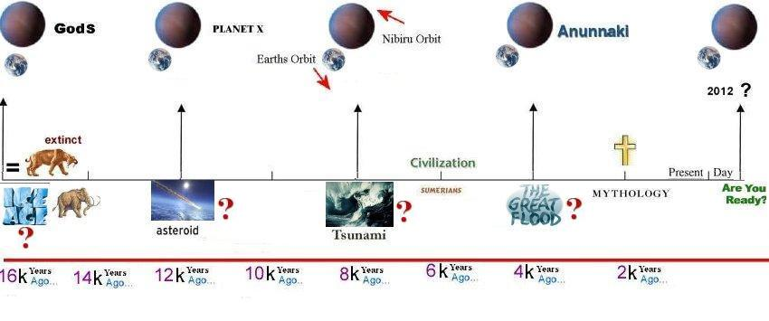
Question mark indicates "what exactly" caused the above events, not if they actually took place - we know they did...
The last 'Major' passage, which caused noticeable catastrophe, was during the Age of Taurus, 4,286 - 2,143 bce - the two before that would have been in the Ages of Leo (10,500 BC.) and Scorpio (14,500 BC.) - (see chart above for "years ago" timeline ).
The Gnostic authors of the Bible were also aware of these hallmark conjunctions, and wrote them into the New Testament. The four beasts of the Apocalypse, the Lion, Ox, Man and Eagle, correspond to the four zodiac signs Leo, Taurus, Aquarius and Scorpio, in which the Grand Cross conjunction of Jupiter and Saturn takes place in 6,444 year intervals.
Even if the authors of the Bible didn't know what exactly would happen at this time (which they probably did) they appear to have used this event as a point for triangulating many prophetic statements. The sign of Taurus, named by the Sumerians 'GU.ANNA', meaning the "Heavenly Bull", also represented the Sumerian God Ishkur, a.k.a Teshub the storm God!
So my conclusion is that we experience catastrophe approximately every 4200 years (2 x 2,148 = 4200) and 3 times within a precessional time scale of 25,776 years. Mayan Elder, Hunbatz Men, also revealed that the Mayans have known about Tzoltze ek' (Nibiru) for many years. They say "The planet has a period of 6,500 years, not 3,600, and visits us 4 times every 26,000 year precessional cycle" (Platonic Year or Great Year, that ends on 21st December 2012). If we go back 6,444 years (3 x 2,148) from 2012 AD, then it brings us to 4,432 BC, when the Antarctic ice cap formed.
There is much controversy over the dating of the Biblical Flood, but if we look at archaeological data for 10,983 BC and 4,432 BC, we see evidence of major flooding and catastrophic climate change. There is also evidence of a flood around 2,200 BC, leading bible scholars to conclude this was the Biblical Flood. But I suggest this flood was much more localized than the great flood, due to the passage of Nibiru at a reasonably safe distance.
Sooooo... Just a coincidence that these other cultures have a 2012 target?
- Hopi Predict a 25yr period of purification followed by End of Fourth World and beginning of the Fifth.
- Mayans Call it the 'end days' or the end of time as we know it.
- Maoris Say that as the veils dissolve there will be a merging of the physical & spiritual worlds.
- Zulu Believe that the whole world will be turned upside down.
- Hindus Kali Yuga (end time of man). The Coming of Kalki & critical mass of Enlightened Ones.
- Incas Call it the 'Age of Meeting Ourselves Again'.
- Aztec Call this the Time of the Sixth Sun. A time of transformation. Creation of new race.
- Dogon Say that the spaceship of the visitors, the Nommo, will return in the form of a blue star
- Pueblo Acknowledge it'll be the emergence into the Fifth World
- Cherokee Their ancient calendar ends exactly at 2012 as does the Mayan calendar.
- Tibetan Kalachakra teachings are prophesies left by Buddha predicting Coming of the Golden Age.
- Egypt According to the Great Pyramid (stone calendar), present time cycle ends in year 2012 AD

Yeah, I'm just a tad concerned. I hope this is not the case and that I'm just completely nuts, but data + data + data = science. I never thought I'd be relaying any sort of Doomsday scenario. And chance's are, these very same Gods will help us out a bit. I just hope we as a species are seen as worthy of such action.
Ok Ok! Some of you might be thinking; "that was just to easy, can this be right? That's the way to think! Obviously, there was mucho more mathmatics that got me to this point in the proof. You just saw the end results. For you math heads that might be curious, here's some of the abstract, is that the correct terminology? (just some notes) that got us to the end result.

